$80 NLH Midnight Madness
Fridays, July 3, 17, 24, & 31, 2026 | 11:59PM
12,000 Starting Stack | 12 Minute Levels

Level | Big Blind Ante | Small Blind | Big Blind
1 | 100 | 100 | 100
2 | 200 | 100 | 200
3 | 300 | 200 | 300
4 | 400 | 200 | 400
5 | 600 | 300 | 600
End Of Registration | 10 Minute Break
6 | 800 | 400 | 800
7 | 1,000 | 500 | 1,000
8 | 1,200 | 600 | 1,200
9 | 1,500 | 1,000 | 1,500
10 | 2,000 | 1,000 | 2,000
10 Minute Break | Color Up 100 Chips
11 | 3,000 | 1,500 | 3,000
12 | 4,000 | 2,000 | 4,000
13 | 6,000 | 3,000 | 6,000
14 | 8,000 | 4,000 | 8,000
Rules:
Players will receive 12,000 in tournament chips.
Registration and re-entry ends at the start of level 6.
A single Ante will be paid from the Big Blind for the entire table. The Big Blind is posted prior to the Ante.
Redraw at final table or by the Tournament Manager's discretion.
Play begins with 4 players checked in at the table.
Rivers Casino Philadelphia reserves the right to change or cancel any tournament. Rivers Casino Philadelphia will not be held responsible in the event of a typographical error or misinformation on the website, Bravo, or any printed material that pertains to their events. Players will not have any claims in these matters.
Seating may be limited.
Residents of foreign countries without a U.S. tax treaty will be subject to withholding.
$56 will go towards the prize pool. $14 registration fee. $7 will be withheld for the Dealers. $3 will be withheld for Tournament Promotional Fund.
Levels will be 12 minutes in length.
Players may forfeit all of their chips at the end of registration to Re-Enter.
All players will start with a full chip stack. Purchased stacks will be put into play at the end of registration if the player is still absent.
Poker Supervisor or above decision is final without recourse.

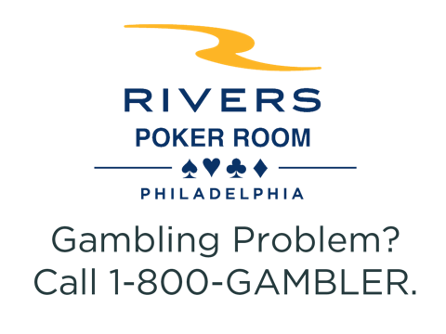
Must be 21 years of age or older to be inside
Rivers Casino. Management reserves all rights.

